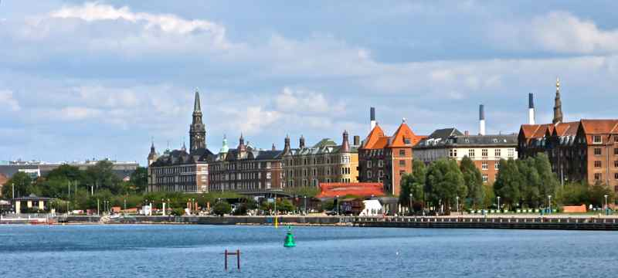

6th Danish Immersion in Davanloo’s ISTDP with Dr. Allan Abbass:

Mastering the Trial Therapy in
Intensive Short – Term Dynamic Psychotherapy

August 20 – 22, 2020 online (Zoom)
Due to the current COVID-19 restrictions, the annual Danish ISTDP immersion will be held through a secure online platform this year. In order to secure confidentiality, participation is restricted to participants who:
- Currently are in core training or supervision in ISTDP, or other emotion-focused therapy models

- Have been in core training in any emotion-focused therapy model, or;

- Who will attend the meeting in the presence of someone in core training, or with prior core training

About the immersion
Intensive Short – Term Dynamic Psychotherapy (ISTDP) begins with an intensive and comprehensive evaluation and treatment session called the Trial Therapy. The trial therapy seeks to establish both a conscious and unconscious therapeutic alliance, gather a complete history of problem areas, past and present relationships, and related medical and social factors, while testing a client’s response to this therapeutic mobilization of the unconscious. By the end of the interview, therapist and patient should both have information about the suitability of this treatment, and what format of the treatment may be most beneficial. The trial therapy is typically conducted in one session, but sometimes over more than one session.
Based on a study of several hundred trial therapies, we have found that the trial therapy is effective in reducing symptoms and interpersonal problems, and also effective in reducing excess healthcare use. There is evidence that it is beneficial in the hands of new learners, and that is more effective than standard psychiatric intake interviews.
In this sixth Danish Immersion in ISTDP, Dr. Allan Abbass and colleagues will provide a detailed video – based study of a series of trial therapies from across the two spectra of patients. Hence, we will look at entire trial therapies of patients with low – to – moderate resistance, and high resistance, as well as patients who suffer from repression and significant fragility. The goal of this course is to assist attendees to master the understanding of functions and processes involved in the trial therapy to help build momentum from the very first session of their treatment courses.
About the speaker
Dr. Allan Abbass
Dr. Allan Abbass is Professor of Psychiatry and Psychology, Director of Psychiatric Education, and founding Director of the Centre for Emotions and Health at Dalhousie University in Halifax, Canada. He is a leading award-winning teacher and researcher in the area of Short -Term Psychodynamic Psychotherapy, with over 250 publications and 300 invited presentations over the globe. These articles can be viewed at www.allanabbass.com
He is known for simplifying the theory and technical aspects of the ISTDP model, with the use of algorithms, and through highlighting moment-to-moment processes that inform interventions. He has received numerous teaching awards, including two national awards in psychiatry, and has been honored with visiting professorships at several international universities and institutions, holds recurrent intensive training programs in Norway, Sweden, Italy, and Canada, and provides internet-based training to professionals and groups around the world.
Dr. Abbass’ critically acclaimed textbook on ISTDP “Reaching Through Resistance: Advanced Psychotherapy Techniques” was published in 2015. His latest book, Hidden from View: A Clinician’s Guide to Psychophysiologic Disorders (Abbass and Schubiner, 2018), deals with psychophysiologic disorders and how health professionals can diagnose and manage these conditions including the use of ISTDP techniques.

Registration Form: 6th Danish ISTDP Immersion

Place: Online via Zoom (participants will receive a link to Zoom in advance)
Dates: August 20 – 22, 2020
Fee: 2.500 Danish Kroner (DKK)

75% refundable until July 30th, 2020
Non-refundable after August 1st, 2020

All attendees will be required to fill in the consent form below before the immersion
Please pay your fee to this account:

Account number: 0002003929
Registration number: 6484
SWIFT/BIC: HANDDKKK
IBAN: DK1064840002003929

Fee is to be transferred in Danish Kroner (DKK) and must include all banking fees.
Please write that this is for “YOUR NAME: DANISH IMMERSION 2020”

Name: ___________________________________________________
Profession: ___________________________________________________
Name of ISTDP or EDT Trainer/Supervisor: ___________________________________________________
E-mail: ___________________________________________________

CONSENT FORM
I declare, that I will not make any audio or video recordings of the clinical material presented during the immersion, and respect all professional, ethical and legal obligations during and after the immersion
Signed: ___________________________________________________

PLEASE FILL IN THE REGISTRATION FORM AND SEND TO: ael@sandlarsen.com

