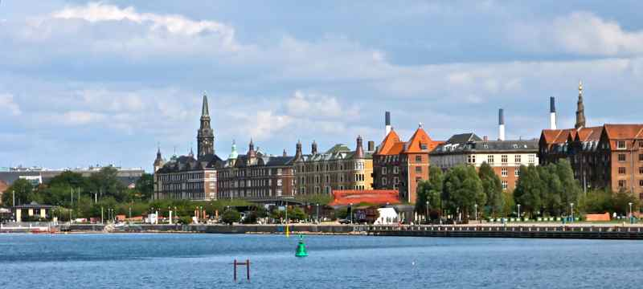

We are pleased to announce the 4th Danish Immersion in Davanloo’s ISTDP with Dr. Allan Abbass:

Treatment of the fragile client: Building capacity and bringing structural change

August 30 – September 1, 2018 at Østerbrohuset, Copenhagen
Fragile Character structure is a common cause of treatment resistance in psychiatric and psychotherapy patients of all diagnostic groups. Frequently misdiagnosed as a range of conditions, these patients are often heavily medicated, hospitalized and become involved in complex, destructive interactions with healthcare systems and therapists.
Intensive Short-term Dynamic Psychotherapy has been specifically developed and researched through thousands of videotape case studies, to provide tailored processes of assessment, capacity building, and working through the intense complex feelings underpinning fragility.
This 3 day immersion course will focus on: The Metapsychology of Fragile Character Structure, Psychodiagnostic assessment, capacity building formats, the use of the technique of bringing structural changes through bracing and the “graded format” of ISTDP. The process of working through will be reviewed as well.
The primary emphasis of the course will be on detailed study of case videotapes, and case discussions.
Participants at the course will learn:
- How to detect fragility
- How to detect the level of fragility
- How to detect and handle rapidly rotating defensive fronts
- How to use pressure, bracing, and recapping to build capacity
- The process of first breakthroughs to the unconscious
- The process of bringing dominance of the UTA over resistance
- The nature of disorganized attachment in severe fragility

About the speaker
Dr. Allan Abbass
Dr. Allan Abbass is Professor of Psychiatry and Psychology, Director of Psychiatric Education, and founding Director of the Centre for Emotions and Health at Dalhousie University in Halifax, Canada. He is a leading award winning teacher and researcher in the area of Short-Term Psychodynamic Psychotherapy, with over 200 publications and 200 invited presentations over the globe. These articles can be viewed at www.allanabbass.com

He is known for simplifying the theory and technical aspects of the ISTDP model, with the use of algorithms and through highlighting moment-to-moment processes that inform interventions. He has received a number of teaching awards, including two national awards in psychiatry, and been honored with visiting professorships at several international universities and institutions, holds recurrent intensive training programs in Norway, Sweden, Italy, and Canada, and provides internet based training to professionals and groups around the world.

Dr. Abbass’ critically acclaimed textbook on ISTDP “Reaching Through Resistance: Advanced Psychotherapy Techniques” was published in 2015. His latest book, Hidden from View: A Clinician’s Guide to Psychophysiologic Disorders (Abbass and Schubiner, 2018), deals with psychophysiologic disorders and how health professionals can diagnose and manage these conditions including the use of ISTDP techniques.

Registration Form: 4th Danish ISTDP Immersion

Location: Østerbrohuset, Århusgade 103, 2100 København Ø
Dates: August 30 – September 1, 2018
Fee: 5.000 Danish Kroner
4.000 Danish Kroner for ISTDP core group members, and members of the Danish Society for ISTDP
3.000 Danish Kroner for full-time students
The fee includes a light morning snack, lunch, coffee/tea, fruit, and a course handout.

Fees are due upon registration to reserve a spot and seating is limited.

75% refundable until June 30th, 2018
Non-refundable after July 1st, 2018

Please pay your fee to this account:

Account number: 0002003929
Registration number: 6484
SWIFT /BIC: HANDDKKK
IBAN: DK1064840002003929

Fee is to be transferred in Danish Kroner and must include all banking fees.
Please write that this is for “YOUR NAME: DANISH IMMERSION 2016”

Name: ___________________________________________________
Profession: ___________________________________________________
City: ___________________________________________________
Mobile phone: ___________________________________________________
E-mail: ___________________________________________________
Food allergies: ___________________________________________________

PLEASE FILL IN THE REGISTRATION FORM AND SEND TO: allan.e.larsen@gmail.com

